DWDM Practical 1

After selecting new project, search for ‘Analysis Services Multidimensional and Data Mining’ then click on next. Name your project and select the location, then click on Create.

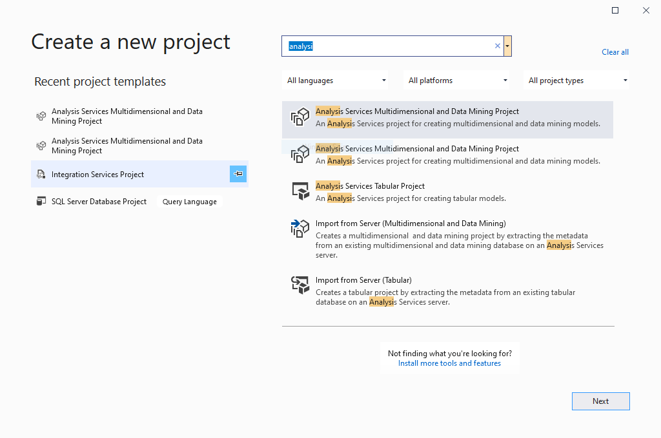

In the solution explorer, right click on ‘Data Source’ and select ‘ New Data Source’.

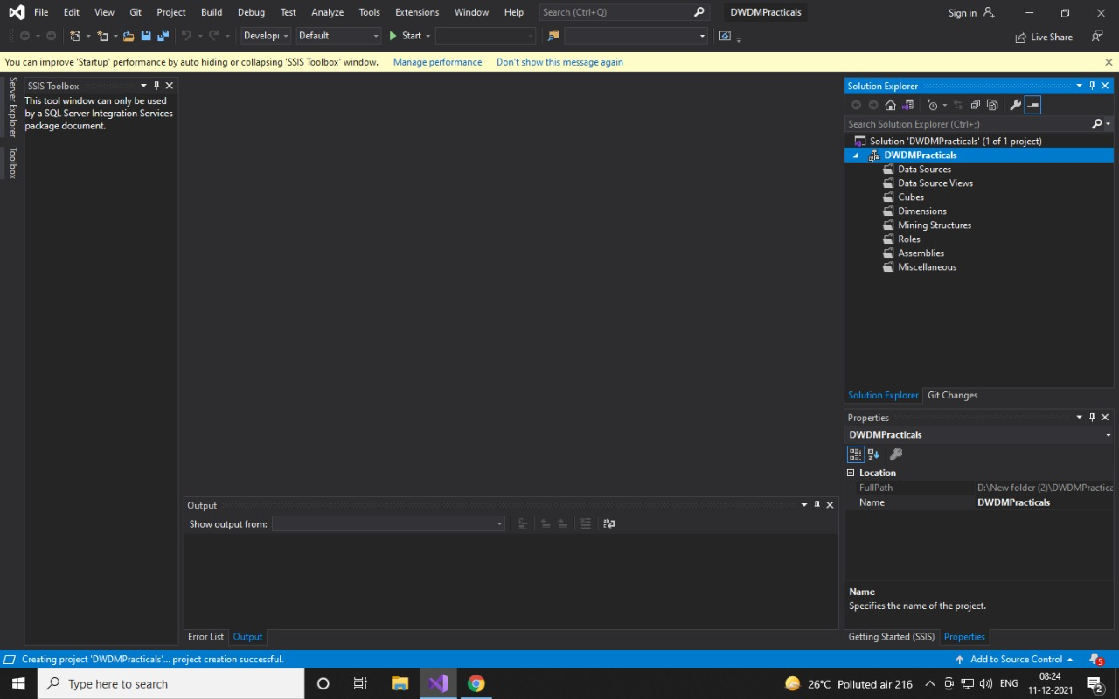

Select how to define the connection for Data Source Wizard.

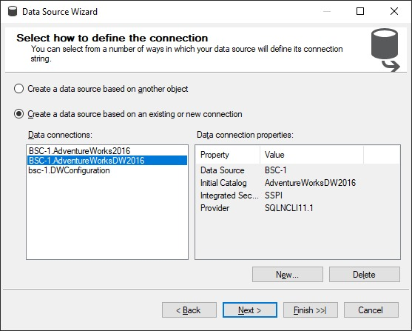

Select Inherit and click Next.

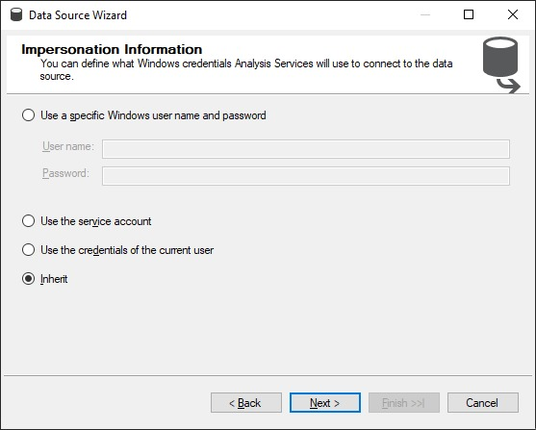

Click Finish.

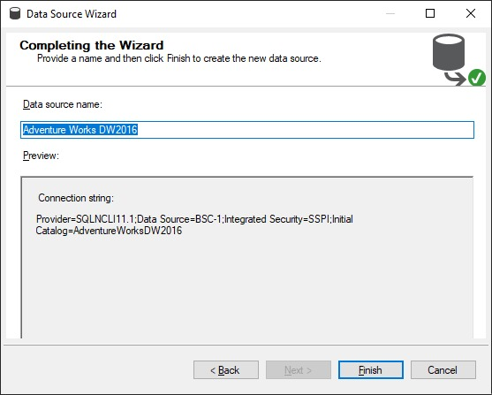

In the solution explorer, right click on Data Source View and Select New Data Source View



Select your Data Source and Click on Next.

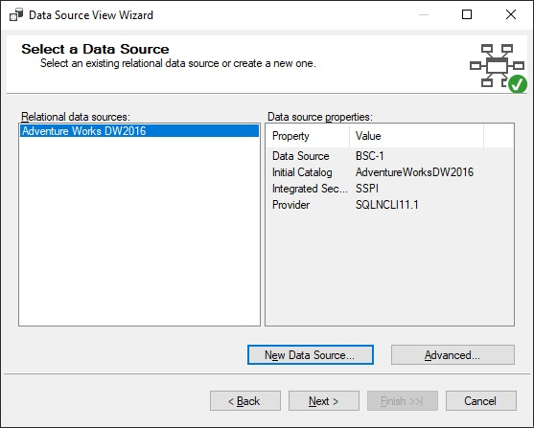

Search required tables using the Filter option.

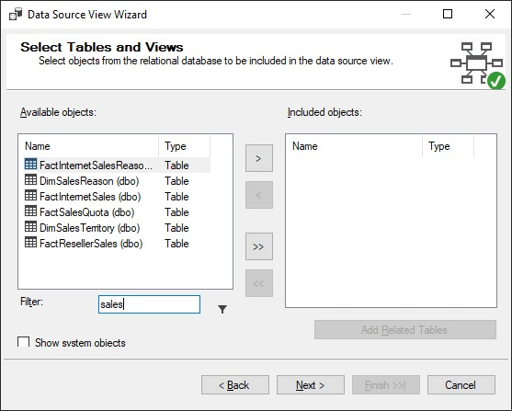

Select the required tables and move to the right-hand side using the > button and click on Next.

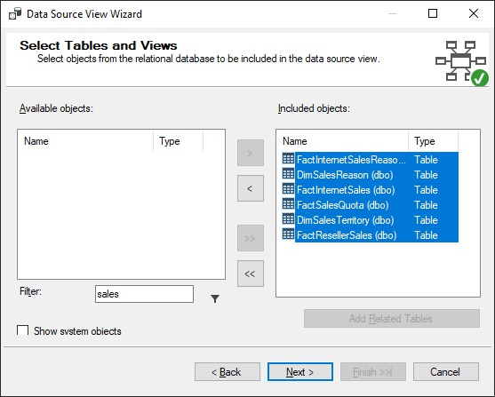

Now Click Finish.

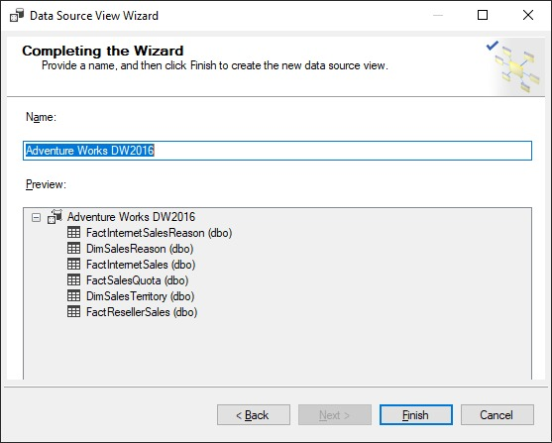

In the solution explorer, right click on Cubes and select New Cube.



Select the first option ‘Use existing tabless’ and click on Next.

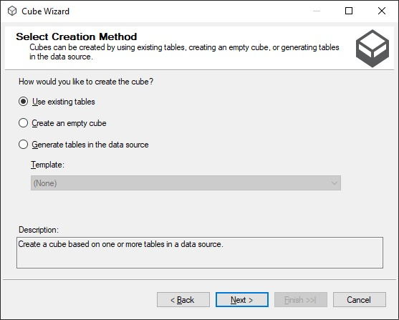

Select the tables and click on Next.

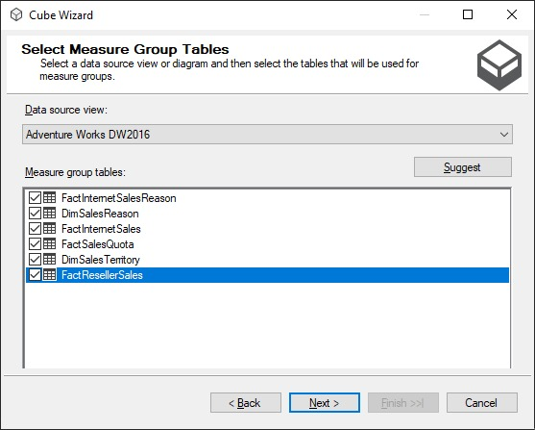

Click on Next and Finish.

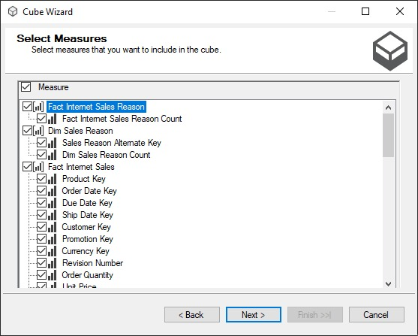

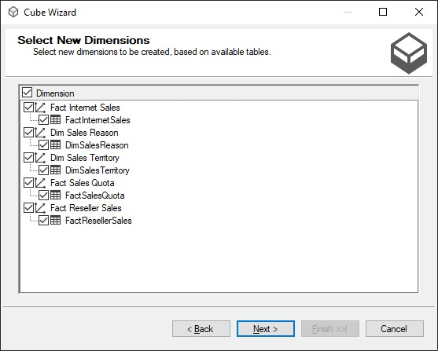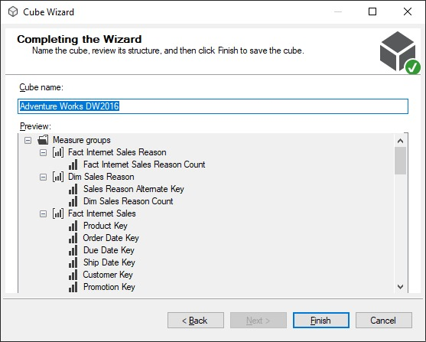

Afterwards you will get the following output.

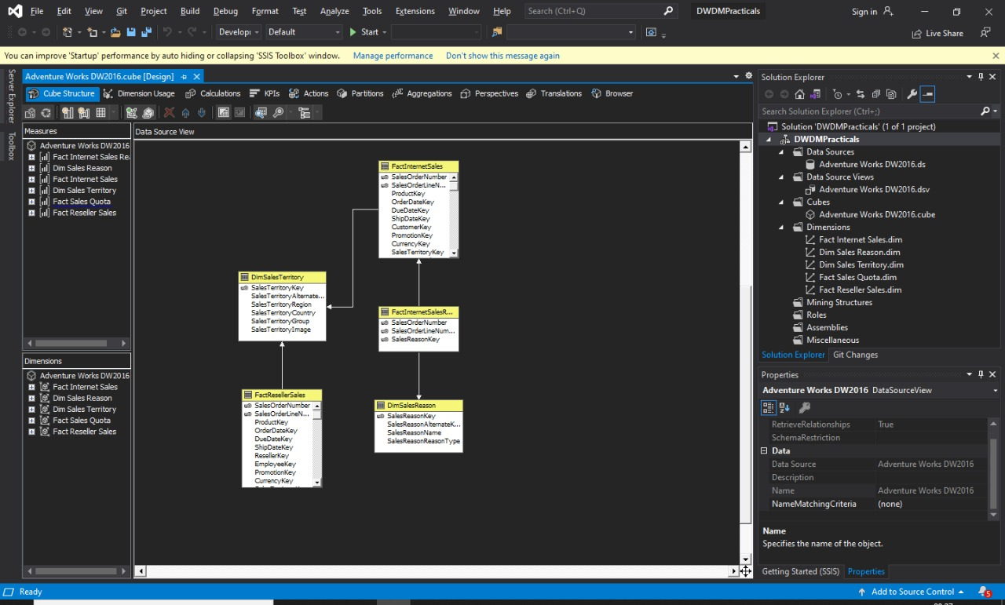

Rename cube name and proceed.

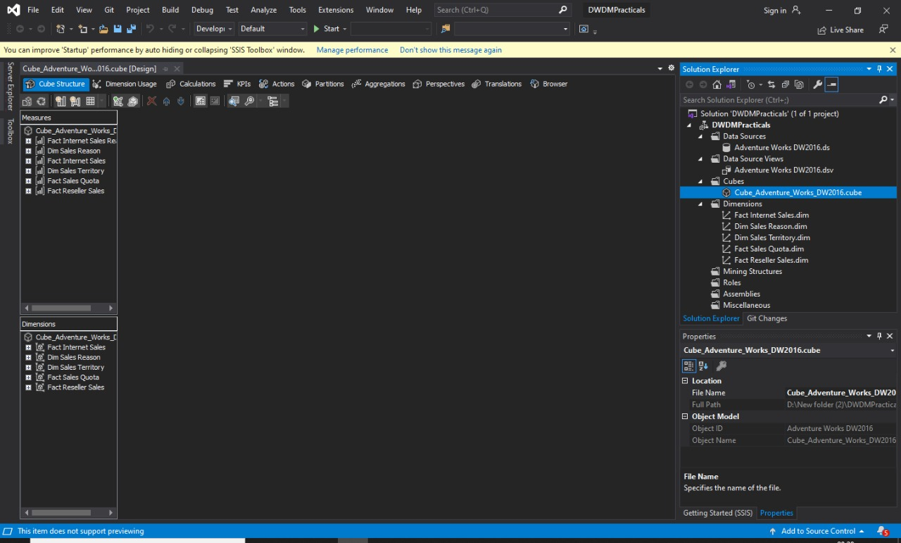

Right Click on the Cube and click on process.

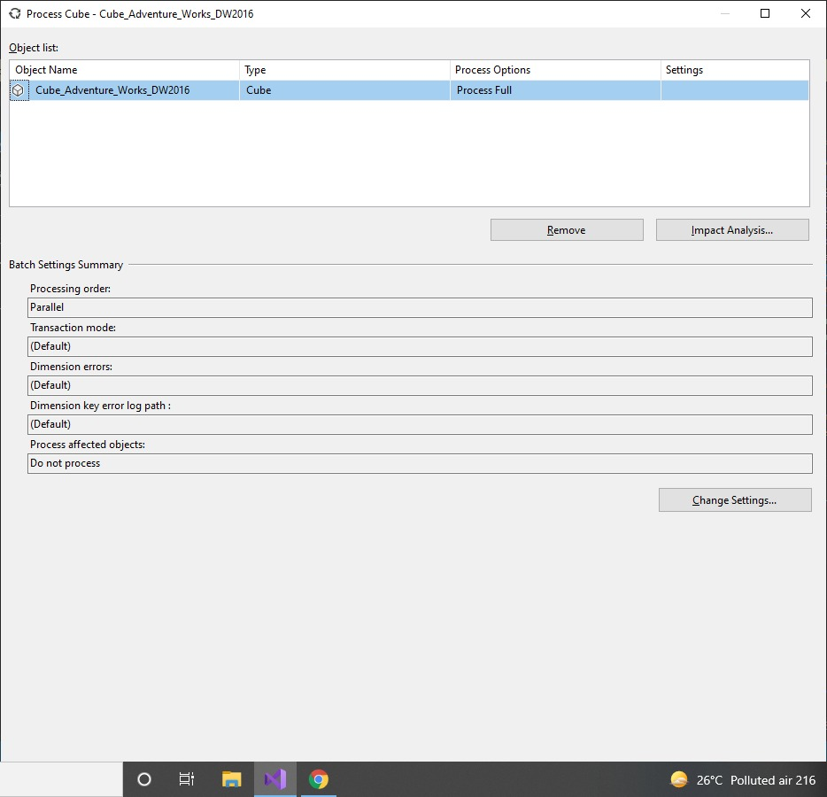

Maximize the window and click on Run

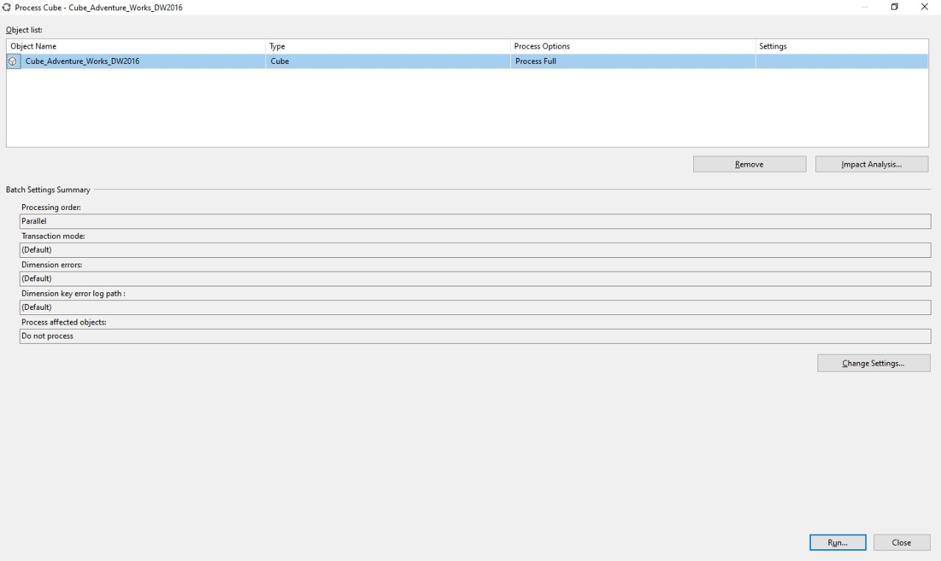

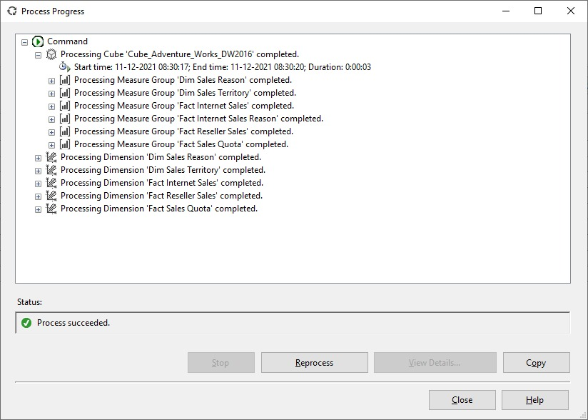

Open Excel sheet, go to Data tab and click on ‘ From other sources and select From analysis services’.

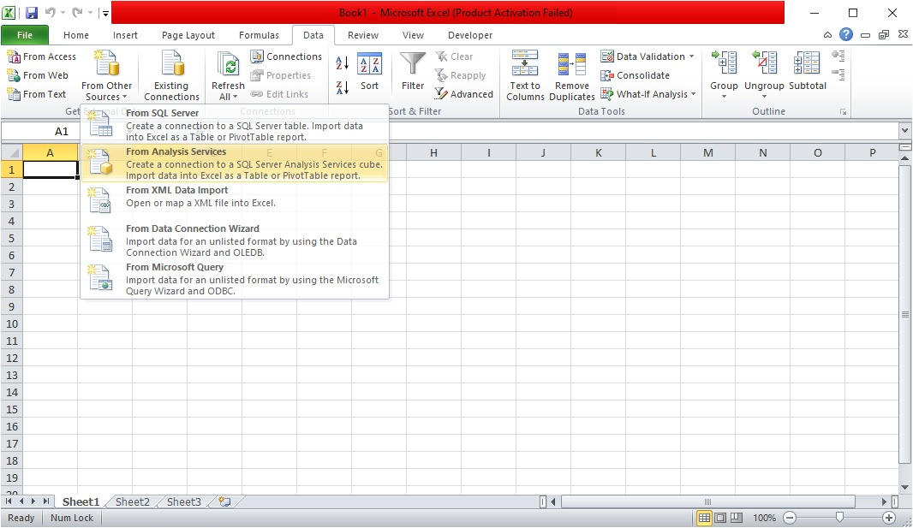

Make the connection.

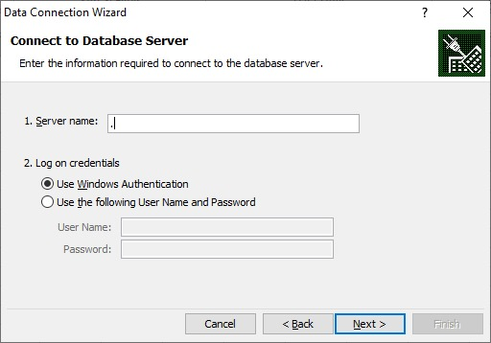

Click on Next and Finish.

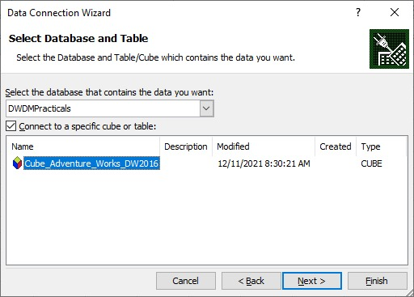

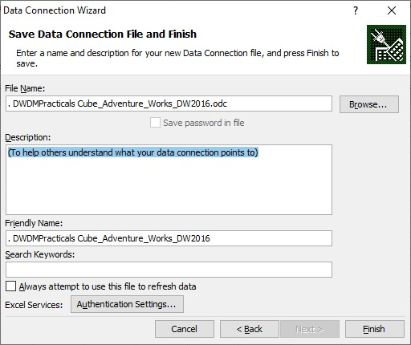

You will get the final representation.

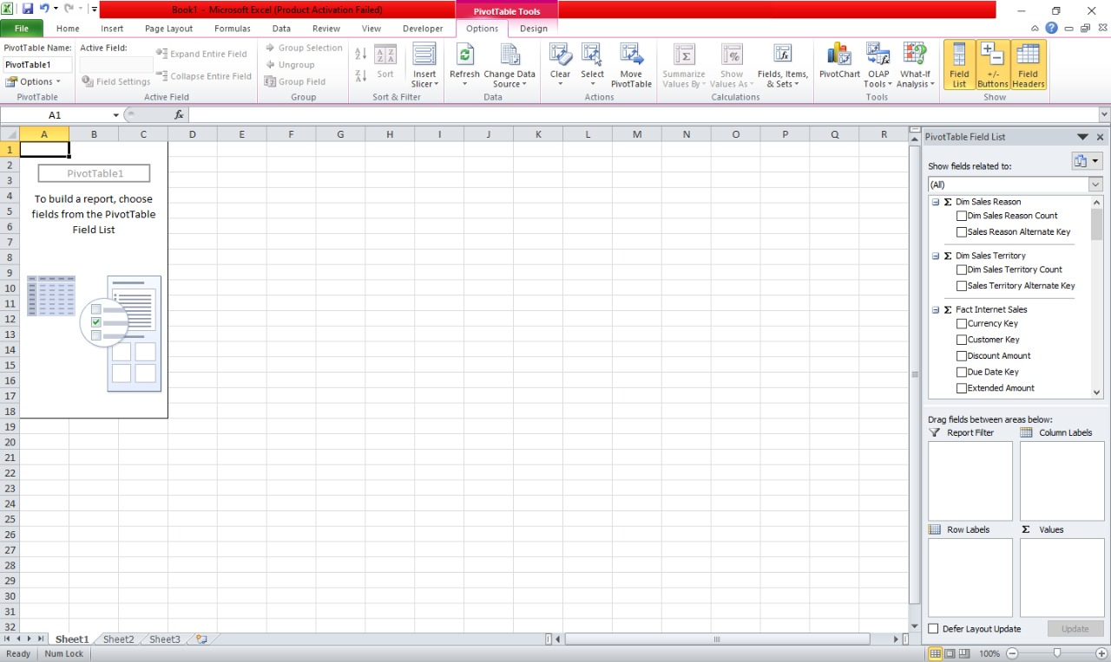

Select the tables from right hand side dialogue box.

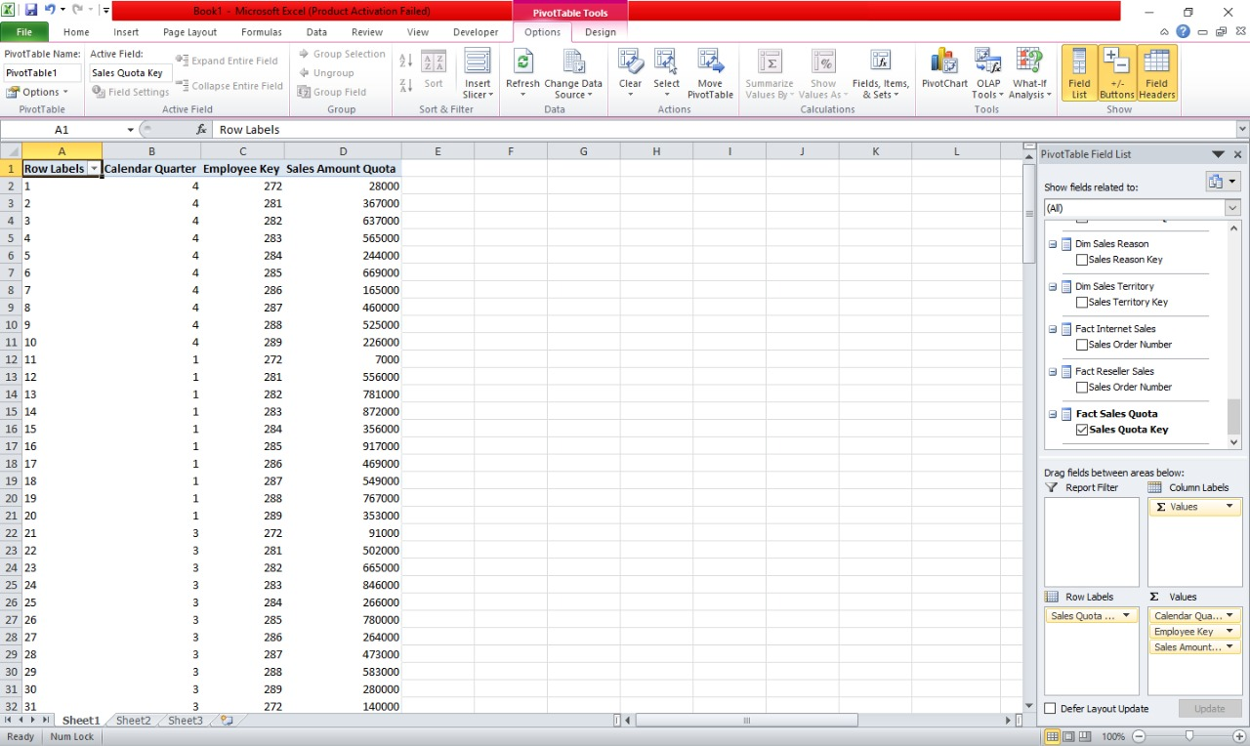

Select all and click on Insert tab and select options from Column. You will get the output as a graph show below.

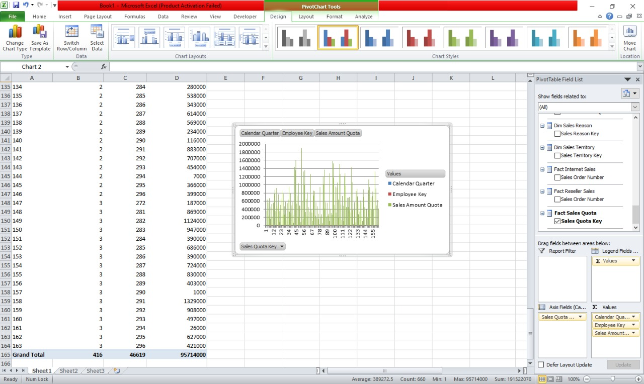

Follow the above same for Pie. You will get the output as a graph show below.

